ARDUINO LASER DISTANCE METER
COMPONENTS:
- Arudino UNO R3
- Breadboard(optional)
- Jumprewire
- Ultrasonic sensore
- Oled 0.96inch
- 2 buttons
- Buzzer
CONNECTION:
The easiest way for power and 5v and GND is straight to + and - pins on breadboard. 1 GND pin you need for the OLED screen.
- OLED: GND-GND pin, VDD-5V, SCK-A5, SDA-A4
- Ultrasonic: VCC-5V, TRIG-10, ECHO-11, GND-GND ON BREADBOARD(-)
- Buzzer: +pin- 7, -pin-GND
- Button: BUTTON for increase distance- 8, BUTTON1 for reduction distance- 9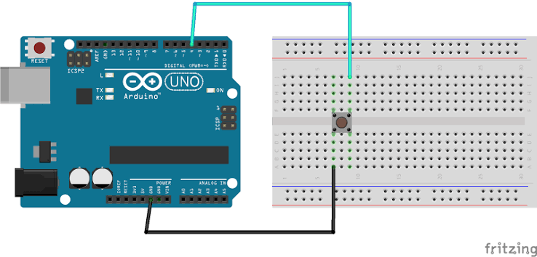
Picture 1: How to connect a button[1]
And program is available on my github.

SOURCE:
- https://roboticsbackend.com/arduino-push-button-tutorial/

